**Write a program that computes the net amount of a bank account based on a transaction log from console input. The transaction log/sample input is in the format as shown below:**

**Input**

log_message = D:100 W:10

**Output**

90

**Input**

Log_message = D:100 W:200 D:400

**Output**

300 (100 - 200 + 400 = 300)

net_amount = 0

log_message = input("Enter the transaction log (e.g., D:100 W:10): ")

# Split the log into transactions

transactions = log_message.split()

# Process each transaction

for transaction in transactions:

# Split the transaction into type (D or W) and amount

transaction_type, amount_str = transaction.split(':')

amount = int(amount_str)

# Update the balance

if transaction_type == 'D':

net_amount += amount

elif transaction_type == 'W':

net_amount -= amount

print("Final balance:", net_amount)

Enter the transaction log (e.g., D:100 W:10): D:100 W:10

Final balance: 90

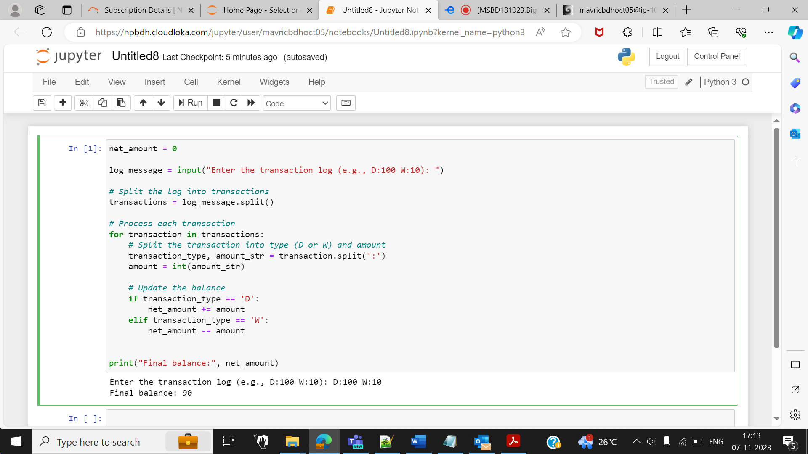

O/P:

Enter the transaction log (e.g., D:100 W:10): D:100 W:200 D:400

Final balance: 300

